**DAILY ONLINE ACTIVITIES SUMMARY**

|  |  |  |  |  |  |  |  |  |
| --- | --- | --- | --- | --- | --- | --- | --- | --- |
| **Date:** | **30/05/2020** | | | | | **Name:** | **VANDANA** | |
| **Sem & Sec** | **IV sem & B section** | | | | | **USN:** | **4AL18CS095** | |
| **Online Test Summary** | | | | | | | | |
| **Subject** | | **1)Data Communication**  **2)Complex analysis, Probability and Statistical Methods** | | | | | | |
| **Max. Marks** | | **1)30**  **2)30** | | **Score** | | | **1)27**  **2)24** | |
| **Certification Course Summary** | | | | | | | | |
| **Course** | **Cloud Foundations** | | | | | | | |
| **Certificate Provider** | | | **Greatlearning academy** | | **Duration** | | | **4.5 hours** |
| **Coding Challenges** | | | | | | | | |
| **Problem Statement1:** Write a C Program to count Uppercase, Lowercase, special character and numeric values for a given String. | | | | | | | | |
| **Status: Executed** | | | | | | | | |
| **Uploaded the report in Github** | | | | | **YES** | | | |
| **If yes Repository name** | | | | | **Online-coding** | | | |
| **Uploaded the report in slack** | | | | | **YES** | | | |

Online Test Summary: 18CS46 test was scheduled from 9:15am t0 10:00am .The portion for the IA was 3rd and 4th module there were 30 questions and the time assigned was 45 minutes the questions were mcq type.

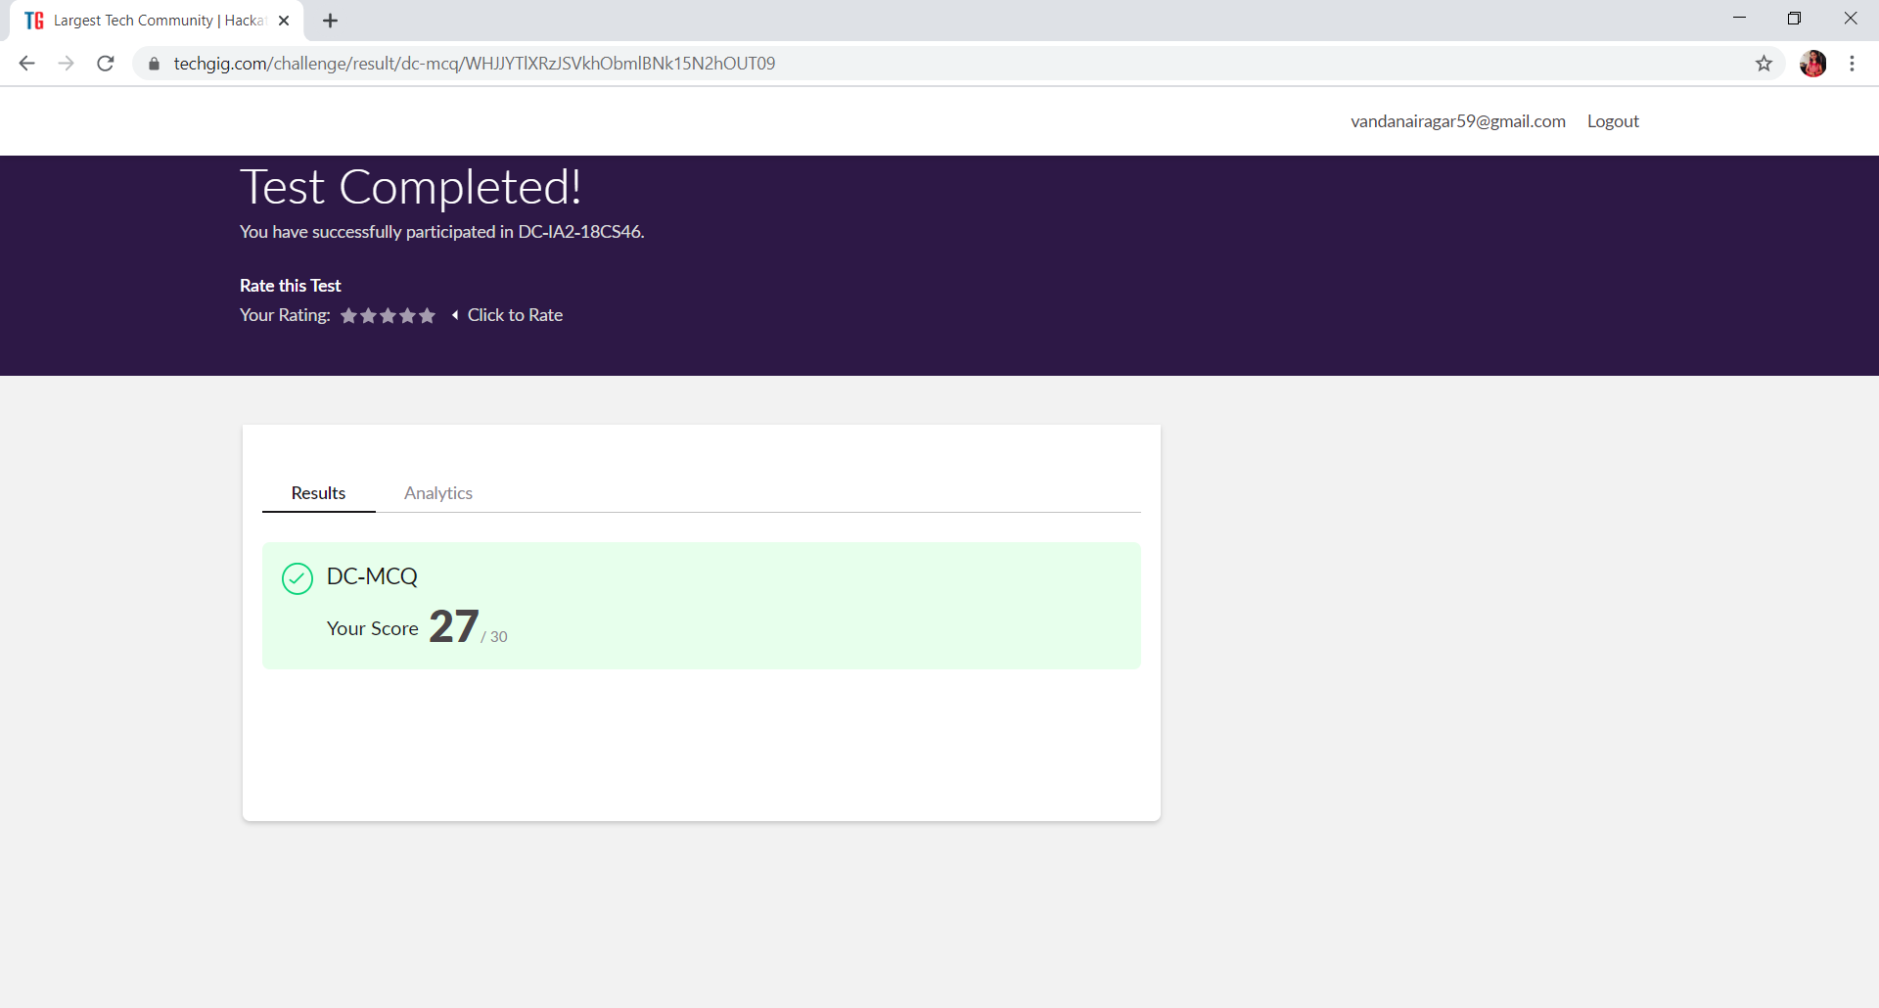

This is the snap shot of completion of test and the marks obtained in 18CS46.

18MAT41 test was scheduled from 2:55pm t0 3:40pm .The portion for the IA was 3rd module there were 30 questions and the time assigned was 40 minutes the questions were mcq type.

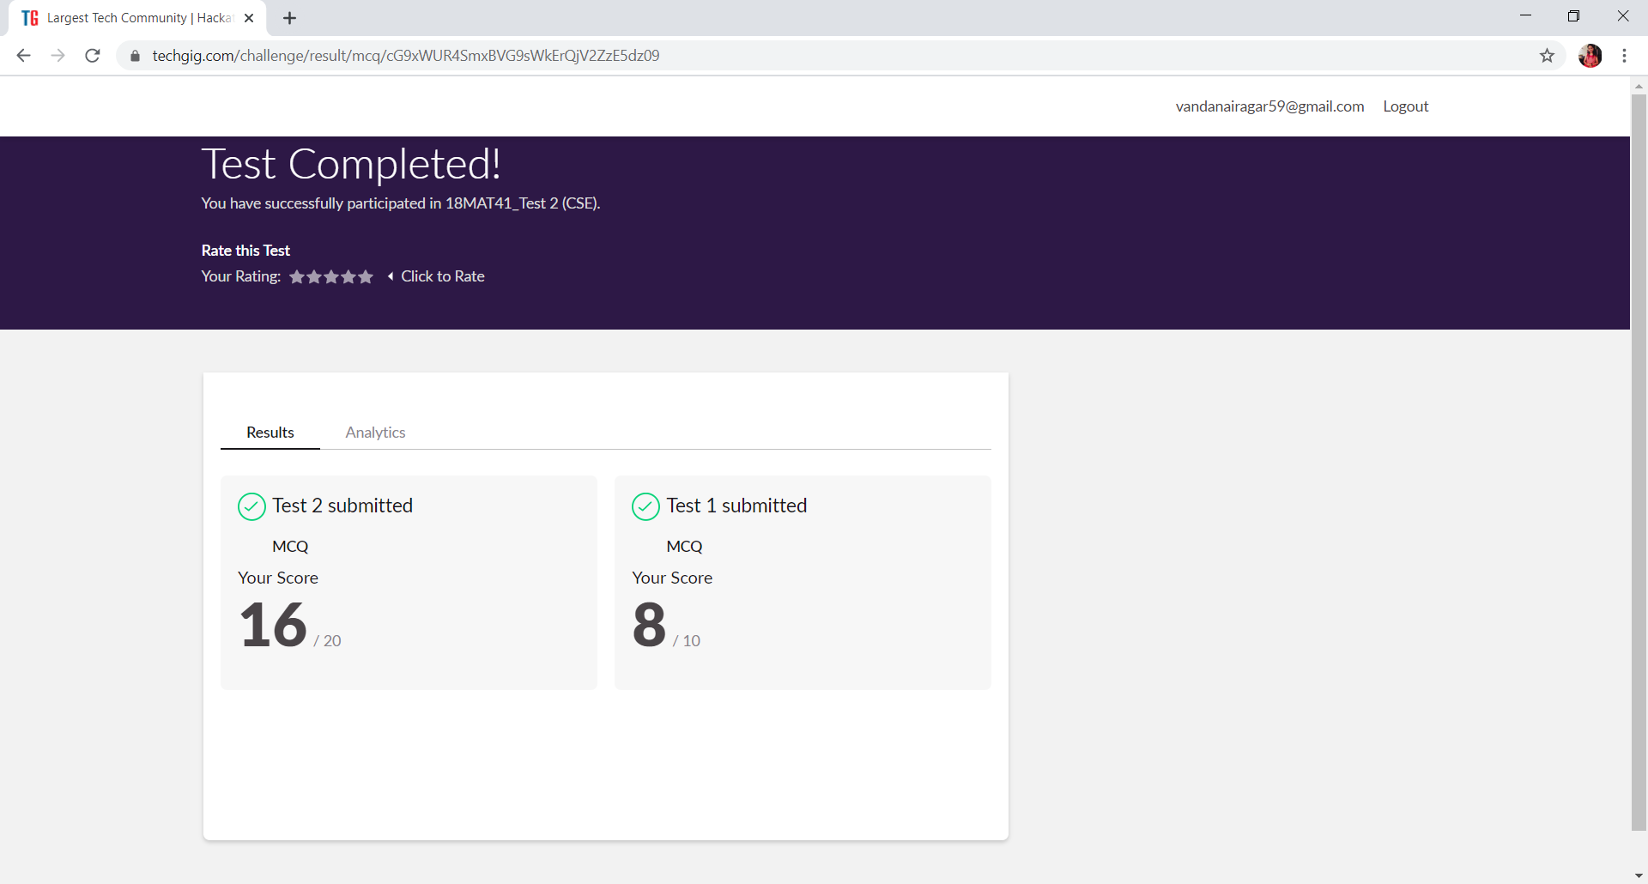

This is the snap shot of completion of test and the marks obtained in 18MAT41.

Online Certification Course Summary: Today I have registered for the new course that is Cloud Foundations. The Faculty is Nirmallya Mukherjee chief Architect at Dell, Principle Architect at Infosys and Technical Architect at Ciber Inc, an HTC Global Services company. In today’s session I came to know what exactly is cloud computing and why is it necessary. And the faculty explained where it is used and told some stories about cloud computing its beginning and how it is ruling in industry or any enterprises nowadays.

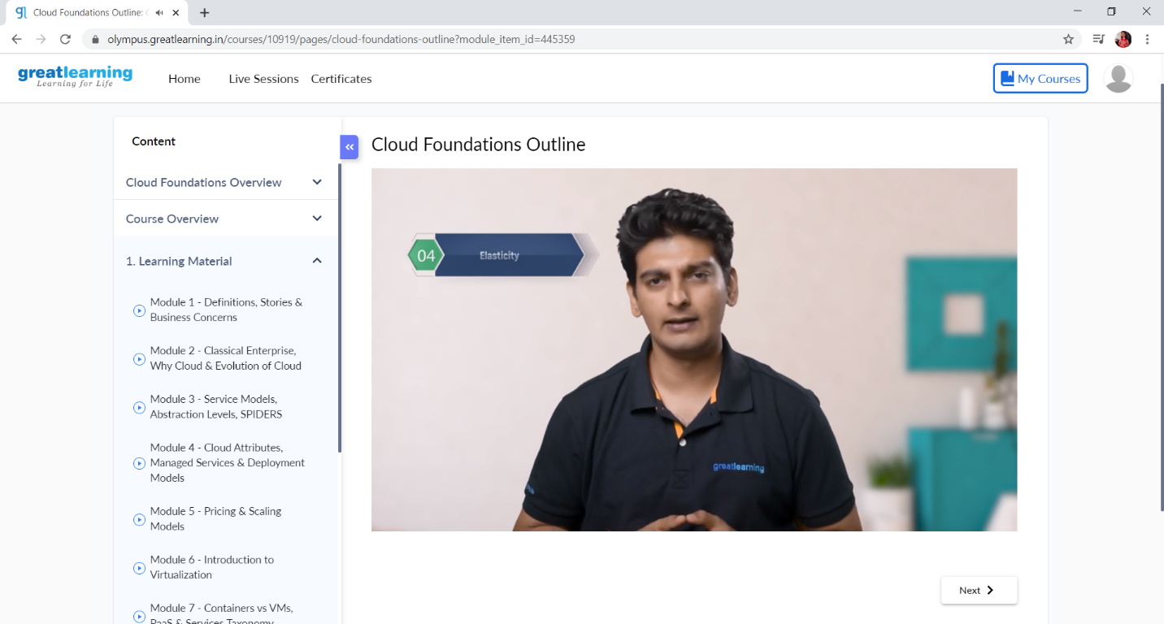

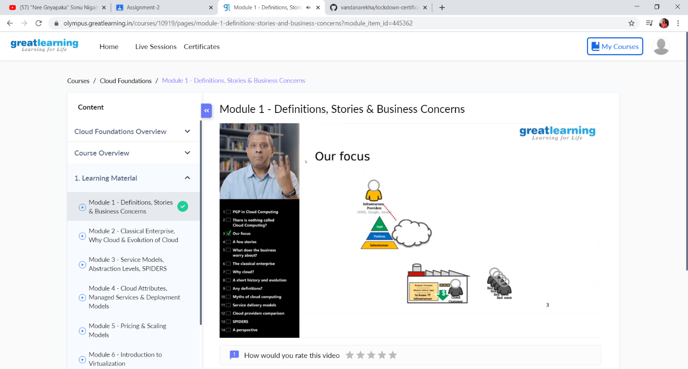

These are the Snap shots of today’s sessions.

Online Coding Summary: **Today I had received one program from prof. Shilpa CSE Dept. The program is mentioned above in the coding challenges(pg.01). I have also uploaded it to my Github repository.**

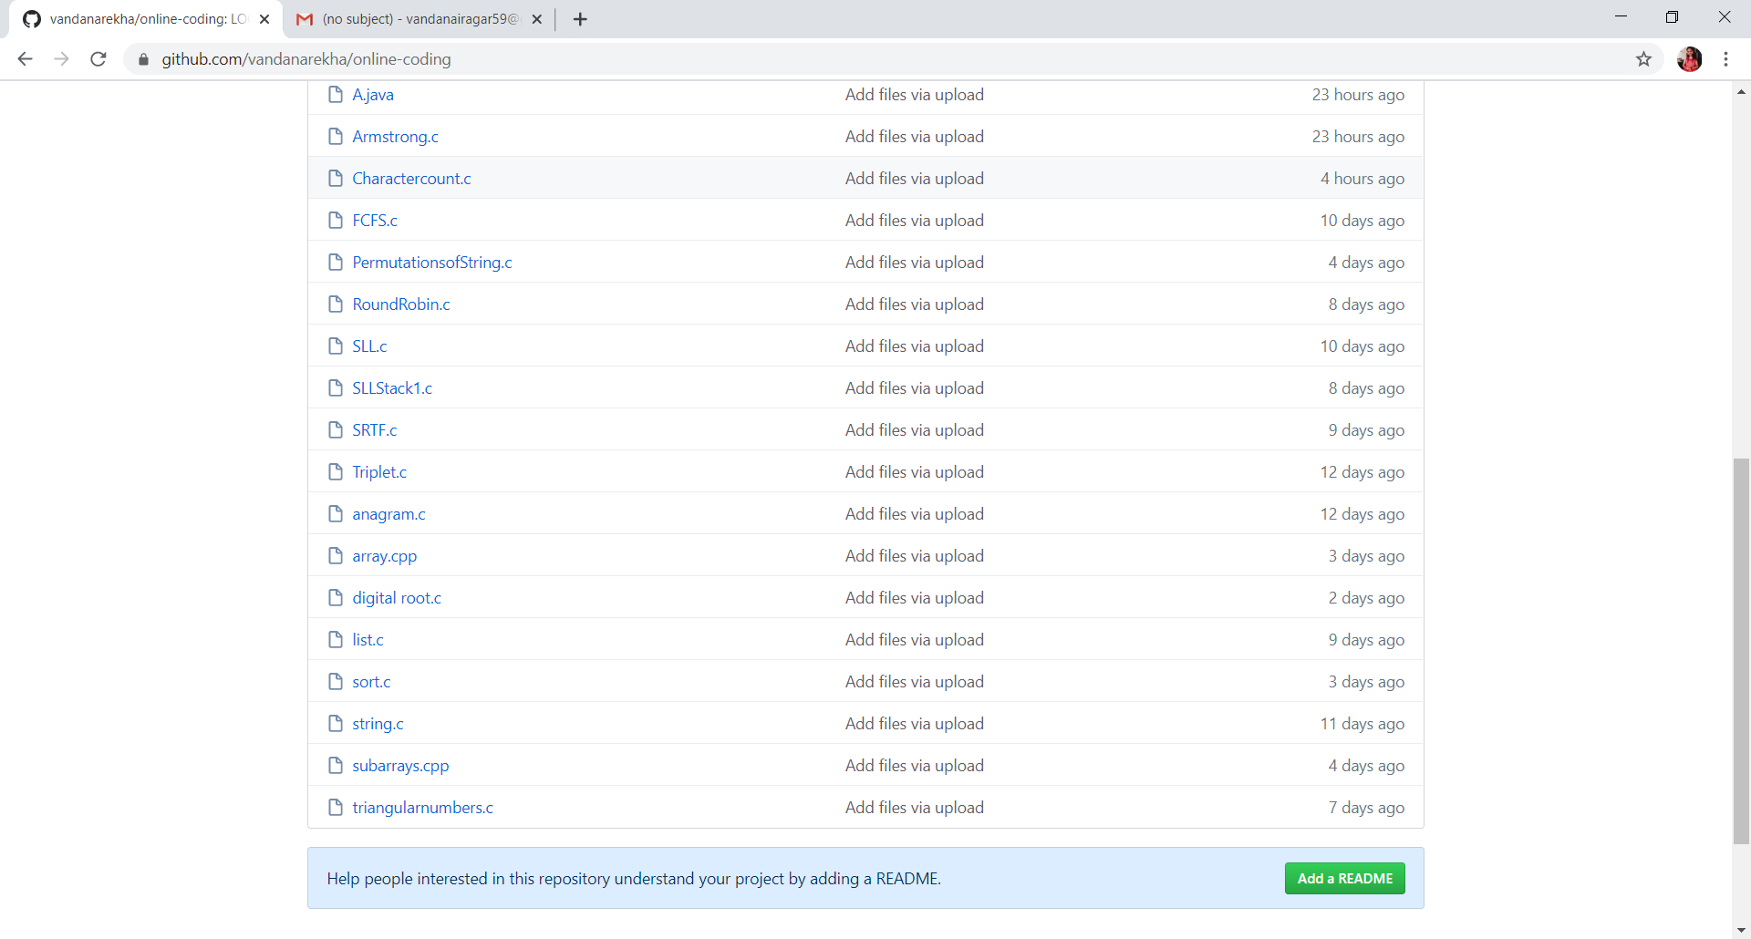

**This is the snap shot of my Github repository** were I have uploaded the code. File name is Charactercount.c